**Logical reasoning Test (set 3)**

**Company name: Reliance jio No. of Question: 10**

**1:**

Find the third word according to the dictionary?

1. Robber
2. Rocket
3. Random
4. Restaurant

**Answer:** option a

**Solution:**

1) Random 2) Restaurant

3) Robber 4) Rocket

**2:**

Which of the two conclusions can be concluded on the basis of given statements?

**Statement:**

All Cats are Dog.

All Dogs are Cow.

**Conclusion:**

1. Some cats and dogs are cow.

2. Some cats are dog.

1. Conclusion 1 is correct.
2. Either Conclusion 1 or 2 is correct.
3. Conclusion 1 and 2 are both correct.
4. Conclusion 2 is correct.

**Answer:** option c

**Solution:**

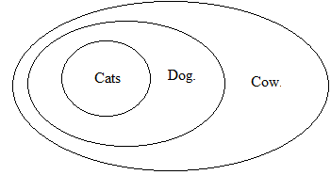

**3:**

What will come at the place of question mark (?)?

CAT: 18 :: COW:?

1. 38
2. 23
3. 35
4. 42

**Answer:** option c

**Solution:**

C = 3, A = 1, T = 20

CAT = 1 + 20 – 3 = 18

C = 3, O = 15, W = 23

COW = 15 + 23 – 3 = 35

**4:**

Meghna drives the car for 10 km in the south and then turns right and drives for 6 km. Once again she turned her right and stopped her car after driving a 10 km. How far is she from her starting position?

1. 4 km
2. 10 km
3. 16 km
4. 6 km

**Answer:** option d

**Solution:**

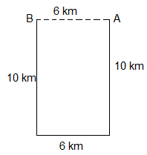

**5:**

A mirror is put on a line AB, find the correct mirror image for the given diagram?

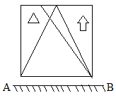

1. 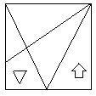
2. 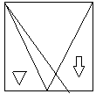
3. 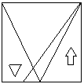
4. 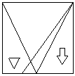

**Answer:** option d

**Solution:**

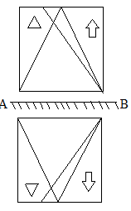

**6:**

Which of following diagram shows the correct relationship between “House, Road, and Garden”?

1. 
2. 
3. 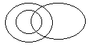
4. 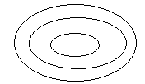

**Answer:** option a

**Solution:**

No relation between house, road, and garden.



**7:**

In the following question, select the term related to the given options.

Valuable : Invaluable : : ?

1. Costly : Cut-Rate
2. Frugality : Wealth
3. Thriftiness : Cheap
4. Miserly-Philanthropic

**Answer:** option a

**Solution:**

The opposite of 'valuable' is 'invaluable' in the same way, opposite of 'costly' is 'cut-rate'.

So, ? Cut-Rate

So, option (1) is correct.

**8:**

In the following question, four numbers are given, three of which are similar in some way, while

the fourth is different. Choose the odd number.

1. 95-82
2. 34-21
3. 69-56
4. 48-34

**Answer:** option d

**Solution:**

In the other pairs, the number on the left is '13' higher than the number on the right side, while in

the option (D) the number on the left is '14' higher than the number on the right side.

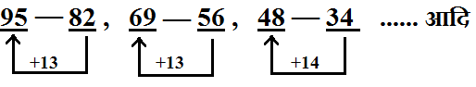

**9:**

If in any code language, 'CHROMATIC' is written as 'XSILNGZRX', how will 'GENERATION'

be written in the same code language ?

1. TVMYIZGRLM
2. TVMVIZGRLM
3. TVNYIGZRLM
4. None of these

**Answer:** option b

**Solution:**

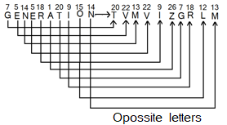

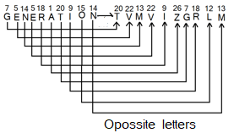

So answer (2 will be correct answer.

**10:**

In the question given below, find the missing number from the given options?

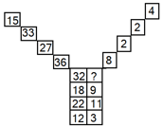

1. 3
2. 4
3. 8
4. 12

**Answer:** option b

**Solution:**

The top left-hand number is obtained by adding the bottom two numbers. The top right hand number is the result of diving the bottom two numbers.

Thus, 12+3=15, 12÷3=4,

22+11=33, 22÷11=2,

18+9=27, 18÷9=2,

32+X=36, 32÷X=8, or X= 4

So, option (2) is the correct answer.